BIG-MAC DATABASE MANAGEMENT SYSTEM

Prepared by:
Jerick T. Comedia
Ronnel F. Oraye
David Mekael Calamdag

Submitted to:
Noemi D. Dioneda, MIT

INTRODUCTION

This project focuses on the design and development of a database system for BigMac, a local food business that handles daily transactions such as customer orders, menu management, and employee records. As the business grows, managing data manually can become inefficient and prone to errors. Therefore, this system aims to organize and store information in a structured and reliable way.
The system was developed to improve data management, ensure accuracy, and make transactions easier to monitor. It includes properly designed entities, attributes, and relationships to reflect real-world operations. Additionally, database queries were implemented to efficiently retrieve and manage data.
Overall, this project demonstrates how database systems can be applied in real-life business scenarios to enhance productivity and decision-making.

OBJECTIVE

CLIENT
Our client is Bernadette Niemo, the owner of a Big-Mac franchise located in Zone 1, Bulan, Sorsogon. She oversees the business operations and ensures the franchise runs smoothly.

PROBLEM & SOLUTION
- Poor Tracking of Sales
- Solution: "The Sales table solves this by recording every transaction clearly."
- Inventory Mismanagement (Out of Stock / Overstock)
- Solution: The Raw_Materials + Menu_Material tables help track, What ingredients are used?, How much stock is left?
- No Clear Recipe/Ingredient Control
- Solution: The Menu_Material table solves this by defining exact recipes.
- Employee Accountability
- Solution: The Employee + Sales tables track: Who made each transaction?

- Lack of Business Insights
- Solution: This system allows: Sales reports, Inventory tracking, Decision-making

REQIREMENTS GATHERING
- Client Data Requirements (What Data the Client Needs to Store) or INPUT
1.Manager Data
The system stores information about managers, including Manager ID, first name, last name, contact number, email (optional), and address. This data is used to identify and manage the person responsible for overseeing employees and operations.

2. Employee Data
The system stores employee information such as Employee ID, first name, last name, age (optional), address, date hired, position (e.g., Crew or Team Leader), salary, employment status (full-time or part-time), and Manager ID. This allows employees to be properly assigned under a specific manager for supervision and accountability.
3. Menu Data (Products Sold)
The system maintains a record of all menu items, including Menu ID, menu name, and price. This ensures that all products sold in the business are properly tracked and managed.
4. Supplier Data
The system stores supplier information such as Supplier ID, supplier name, contact number (optional), and address. This helps the business manage where raw materials are sourced.
5. Raw Materials (Inventory)
The system tracks raw materials used in production, including Material ID, material name, stock quantity, unit of measurement (such as pcs, pack, or box), and Supplier ID. This ensures proper inventory monitoring and control of all ingredients.
6. Sales Data (Core Transaction)
The system records all sales transactions, including Sales ID, Menu ID, Employee ID, sale date, start time, end time, and quantity sold. This allows the business to track every transaction made per employee and per product.

- System Processes (What the System Does) or PROCESS

1. Sales Processing
The system records every item sold in real-time, links each sale to the responsible employee and menu item, and calculates the total quantity sold per shift.
2. Inventory Tracking Process
The system automatically deducts raw materials based on the menu items sold. It uses the Menu_Material table to determine ingredient consumption and continuously monitors stock levels to ensure availability.
3. Employee Performance Tracking
The system tracks the number of sales made by each employee, evaluates productivity per shift, and links performance results to their assigned manager for supervision and evaluation.
4. Reporting Process
The system generates various reports, including daily sales reports, employee performance reports, inventory usage reports, and reports identifying the top-selling menu items.

- System Outputs (What the System Produces) or OUTPUTS
1.Sales Reports
The system produces reports showing total sales per day, sales per employee, and sales per menu item. These reports help the business understand sales performance and trends.
2. Employee Reports
The system generates reports showing the total items sold per employee, shift performance based on start and end times, and attendance insights based on sales activity.
3. Inventory Reports
The system provides reports on current stock levels, low-stock alerts, and material consumption per menu item to help manage inventory efficiently.
4. Product Performance Reports
The system identifies the best-selling and least-selling menu items and calculates revenue generated per menu item to support business decisions.
5. Supplier Reports
The system generates reports showing which materials are supplied by each supplier and tracks dependency on suppliers for inventory management.

- User Requirements (What the Client Expects the System to Do)
- The BigMac franchise owner expects the system to function as a complete business management tool that improves operations and decision-making.
1. Track All Sales Automatically
The system must automatically record every sale along with the employee responsible and the time of transaction, eliminating the need for manual computation.
2. Monitor Employee Performance:
The system must identify top-performing employees, track productivity per shift, and assign accountability for every sale made.

3.Manage Inventory Efficiently:
The system must maintain accurate stock levels of all raw materials, prevent shortages and overstocking, and automatically connect ingredients to menu items for real-time inventory control.
4. Improve Business Decision-Making:
The system must help identify best-selling products, support menu and pricing adjustments based on data, and improve staffing decisions for each shift based on performance and sales trends.

SYSTEM PROPOSAL
System Overview
The proposed system is a "Big-Mac Database Management System" designed for the Big-Mac Franchise in Zone 1, Bulan, Sorsogon. It centralizes and automates the management of sales, employees, inventory, menu items, suppliers, and raw materials into a single integrated database system.
The system is designed to replace manual and fragmented record-keeping methods with a structured relational database that ensures accuracy, efficiency, and real-time data tracking.
By linking sales, inventory, and employee performance data, the system enables the business to monitor operations effectively and make data-driven decisions.
Key Features of the System
The proposed database system includes the following key features:
1. Automated Sales Recording – Every transaction is stored with employee and timestamp details
2. Inventory Monitoring System – Tracking of raw material usage and stock levels
3. Menu Recipe Management – Defined ingredient structure per menu item
4. Employee Performance Tracking – Sales-based evaluation of employees per shift
5. Supplier Management System – Tracks material sources and supplier relationships
6. Reporting System – Generates sales, inventory, and performance reports
7. Relational Database Structure – Ensures data consistency using foreign keys and relationships

Expected Benefits
The implementation of this system will provide the following benefits:
- Improved Sales Accuracy
All sales transactions are recorded systematically, reducing human error and ensuring accurate financial records.
- Efficient Inventory Control
The system prevents overstocking and shortages by monitoring material usage.
- Consistent Product Quality
Defined recipes ensure that all menu items are prepared with correct ingredients and measurements.
- Better Employee Accountability
Each sale is linked to an employee, making performance evaluation transparent and measurable.
- Strong Business Decision-Making
Management can easily identify trends such as best-selling products, peak hours, and employee productivity.

ENTITY RELATIONSHIP DIAGRAM
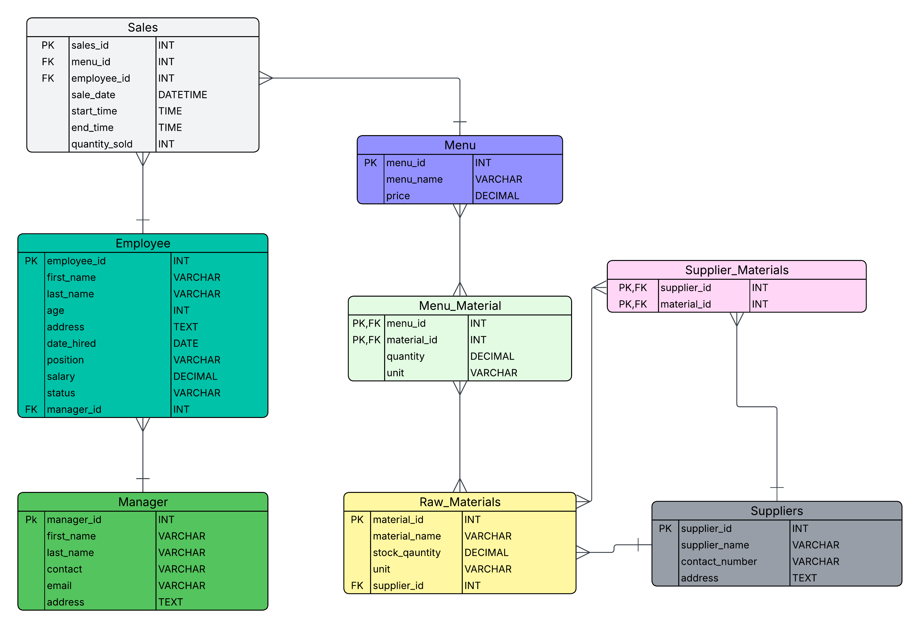
Manager Table
The Manager table contains information about managers, including their contact details. Its Primary Key (PK) is manager_id. It does not have foreign keys but is referenced by the Employee table. The cardinality is one-to-many from Manager to Employee (one manager supervises many employees).
Employee Table
The Employee table stores all worker details such as name, position, salary, and status. Its Primary Key (PK) is employee_id. It has a Foreign Key (FK) manager_id that links to the Manager table. The cardinality is many-to-one from Employee to Manager (many employees are supervised by one manager) and one-to-many from Employee to Sales (one employee can handle many sales).

Sales Table
The Sales table records every transaction made in the restaurant, including what item was sold, who handled it, and when it happened. Its Primary Key (PK) is sales_id, which uniquely identifies each sale. It has two Foreign Keys (FK): menu_id (linked to Menu) and employee_id (linked to Employee). The cardinality is many-to-one from Sales to Menu (many sales can involve one menu item) and many-to-one from Sales to Employee (many sales can be handled by one employee).
Menu Table
The Menu table contains all food items offered, including their names and prices. Its Primary Key (PK) is menu_id, which uniquely identifies each menu item. It has no direct foreign keys but is referenced by other tables like Sales and Menu_Material. The cardinality is one-to-many from Menu to Sales (one menu item can appear in many sales) and many-to-many with Raw_Materials through Menu_Material.
Menu_Material Table
The Menu_Material table connects Menu and Raw_Materials to define recipes. It uses a composite Primary Key (PK) made of menu_id and material_id. Both fields are also Foreign Keys (FKs) linking to Menu and Raw_Materials. The cardinality is many-to-many between Menu and Raw_Materials, resolved by this table (one menu uses many materials, and one material is used in many menu items).
Raw_Materials Table
The Raw_Materials table tracks all ingredients, including their stock quantity and unit. Its Primary Key (PK) is material_id. It has a Foreign Key (FK) supplier_id that links to the Suppliers table. The cardinality is many-to-one from Raw_Materials to Suppliers (many materials can come from one supplier) and many-to-many with Menu through Menu_Material.
Supplier_Materials Table
The Supplier_Materials table links suppliers and materials, allowing flexible sourcing. It uses a composite Primary Key (PK) of supplier_id and material_id. Both are also Foreign Keys (FKs) referencing Suppliers and Raw_Materials. The cardinality is many-to-many between Suppliers and Raw_Materials, meaning multiple suppliers can provide the same material and vice versa.
Suppliers Table
The Suppliers table stores supplier information such as name, contact number, and address. Its Primary Key (PK) is supplier_id. It does not directly depend on other tables but is referenced by Raw_Materials and Supplier_Materials. The cardinality is one-to-many from Suppliers to Raw_Materials and many-to-many with Raw_Materials through Supplier_Materials.

DATABASE SCHEMA
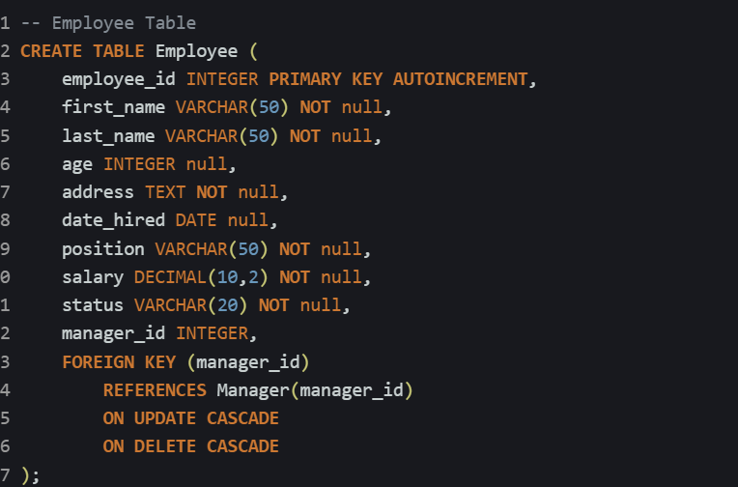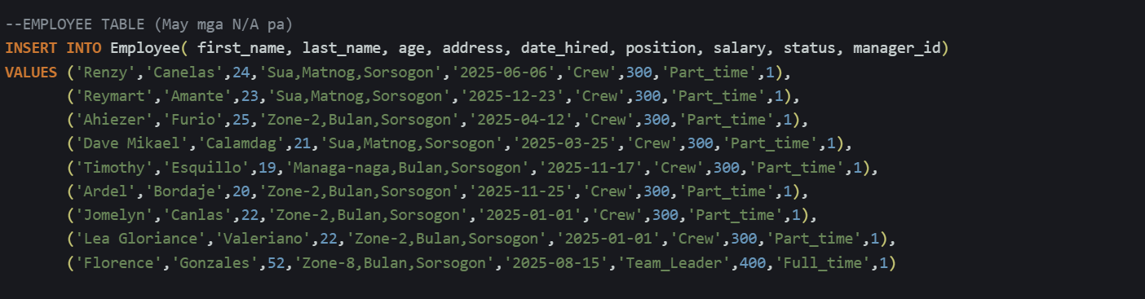
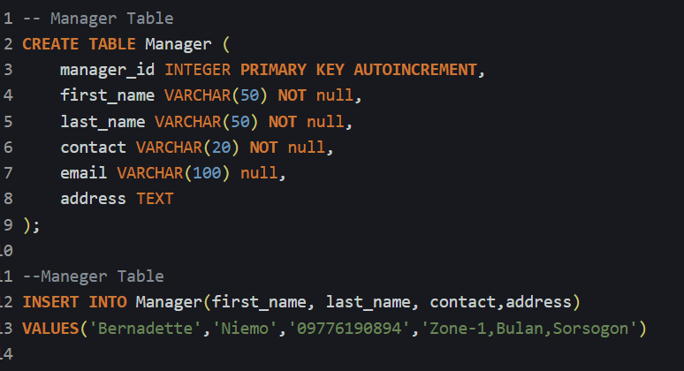

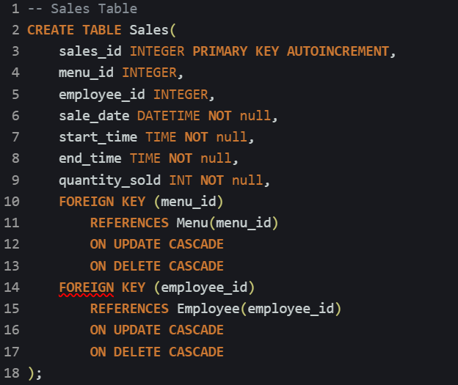
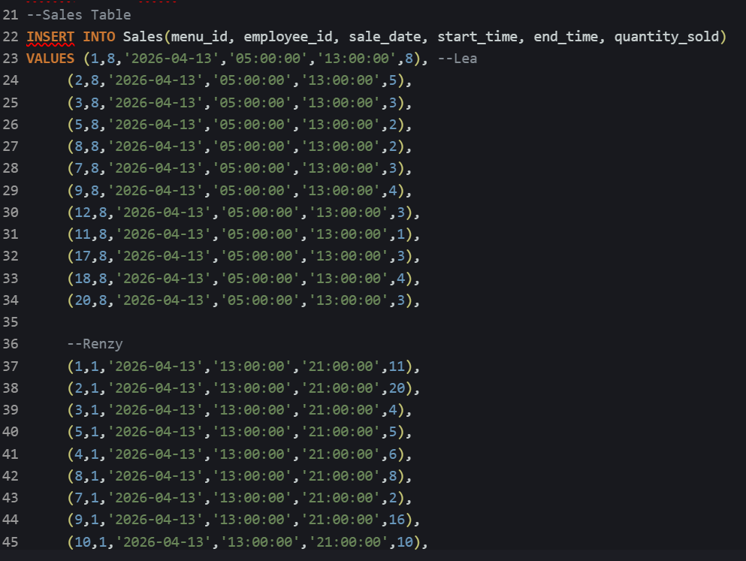

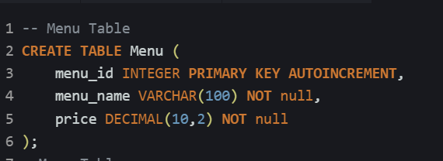
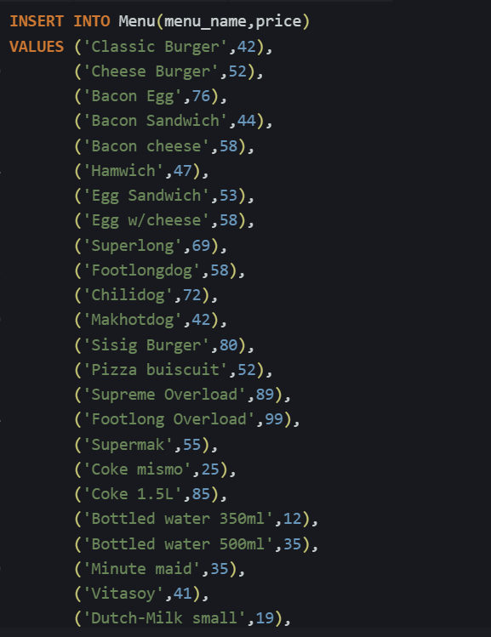

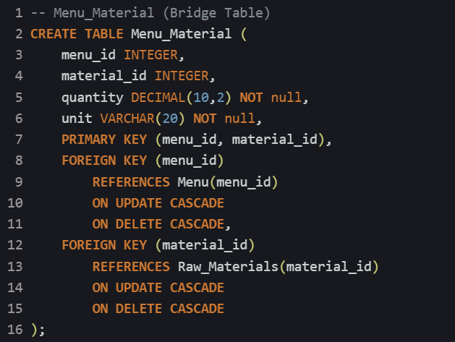
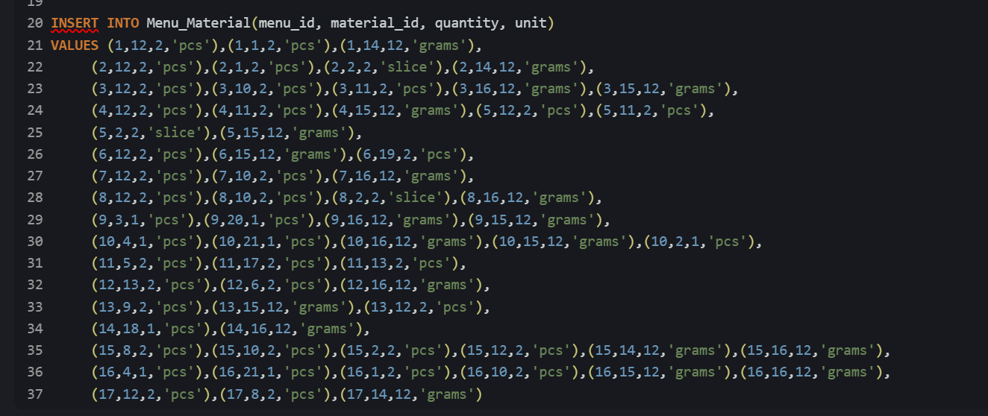
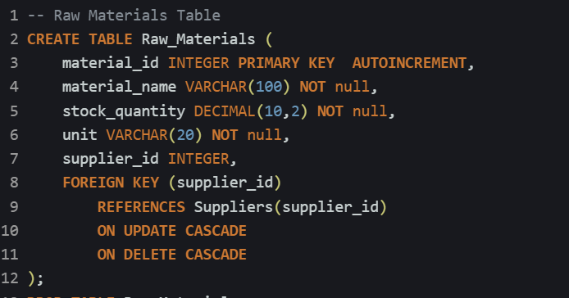
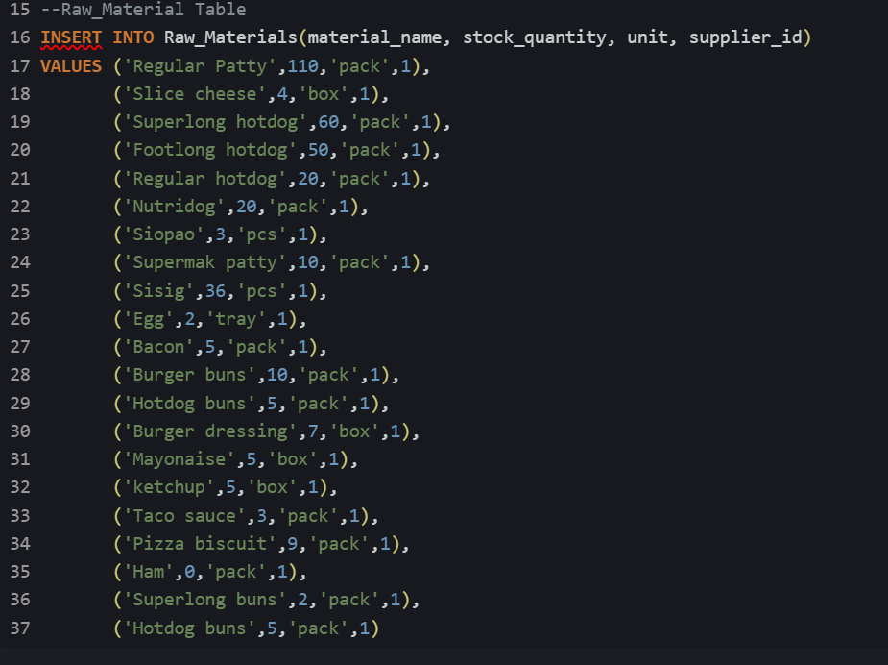

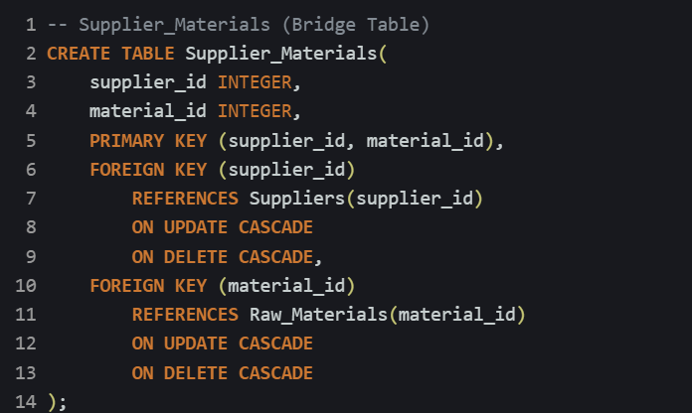
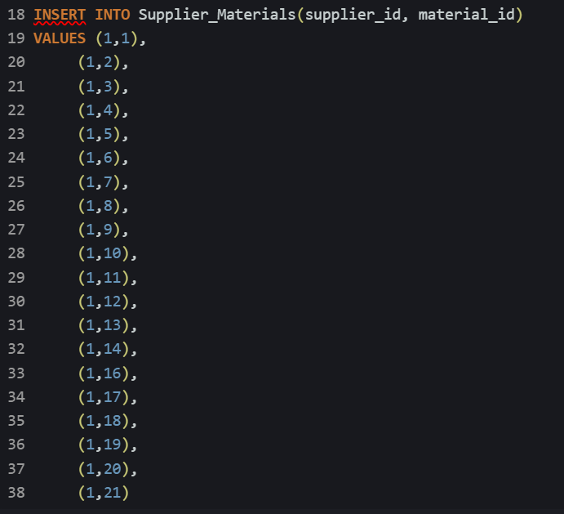

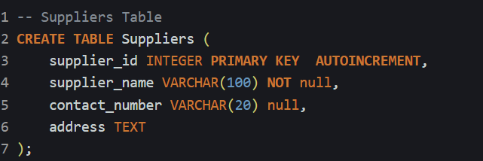
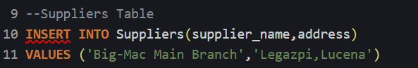
SYSTEM REPORT
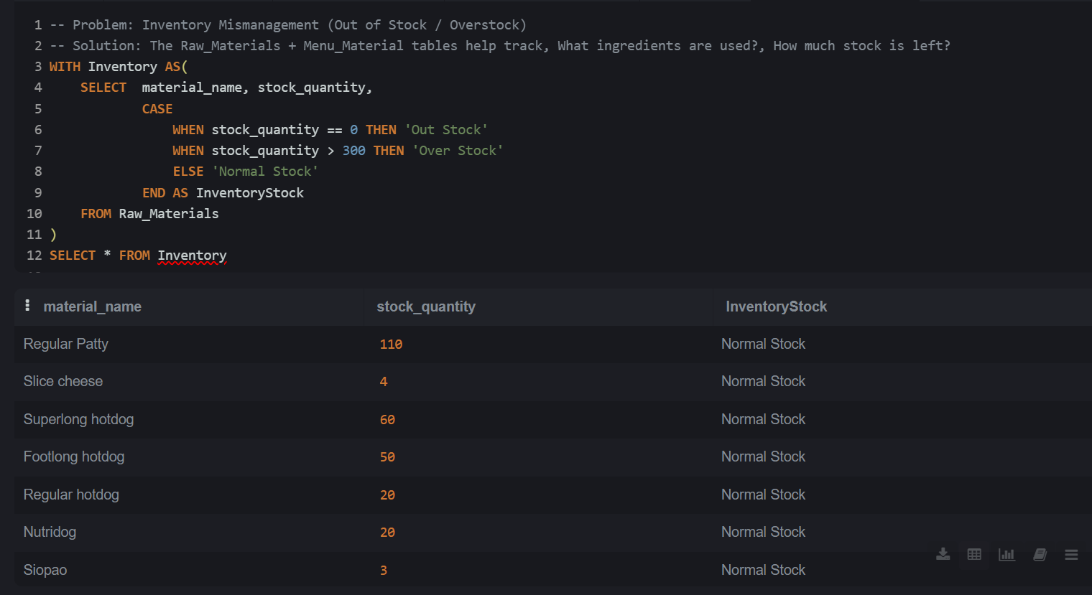
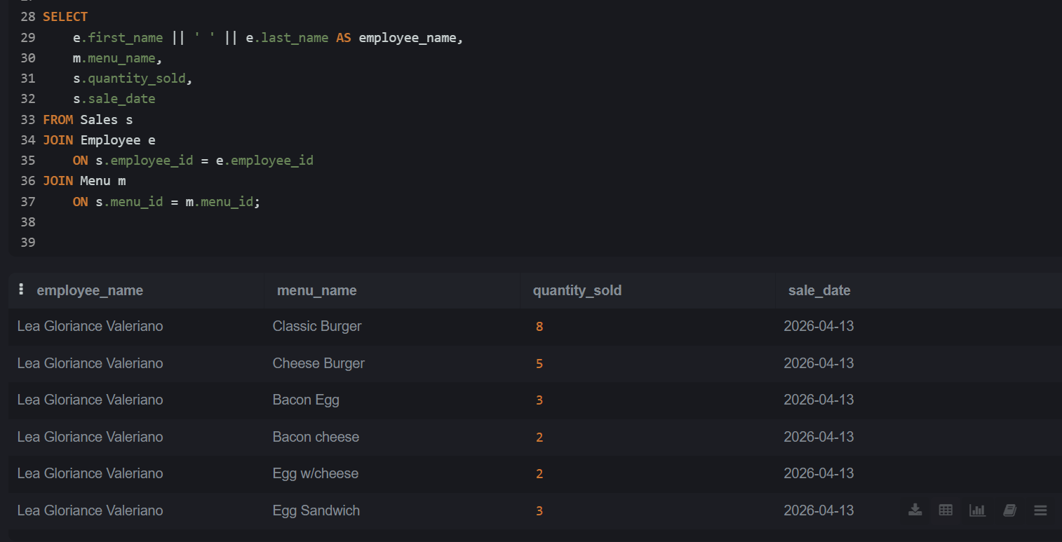
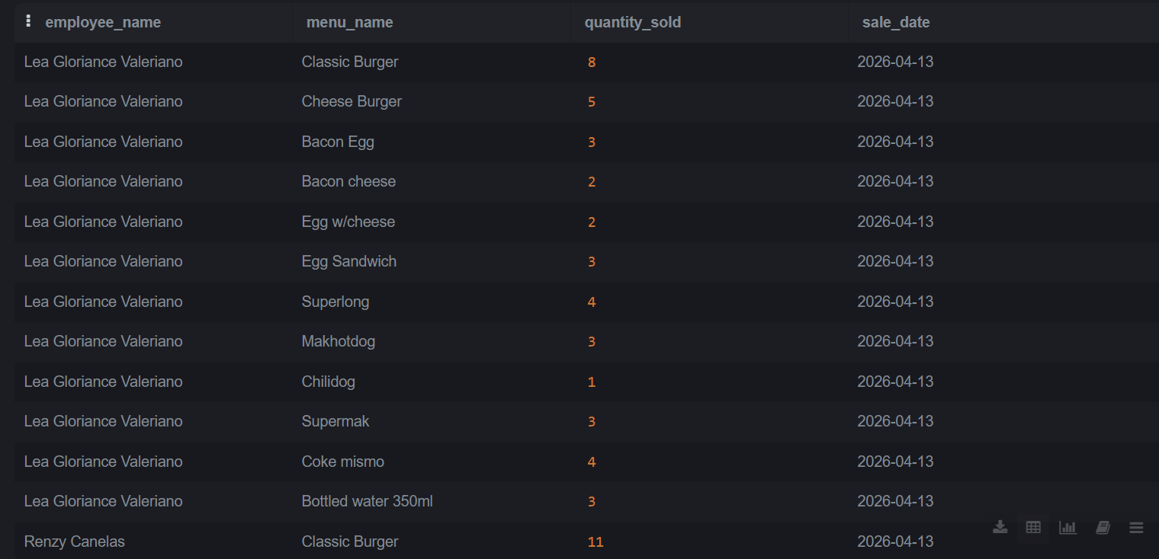
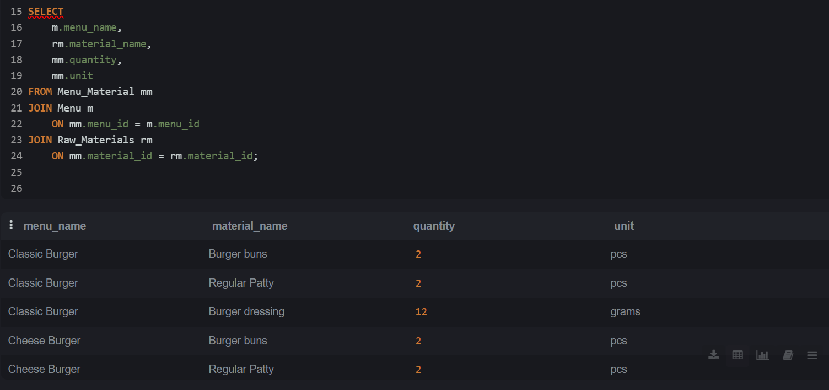
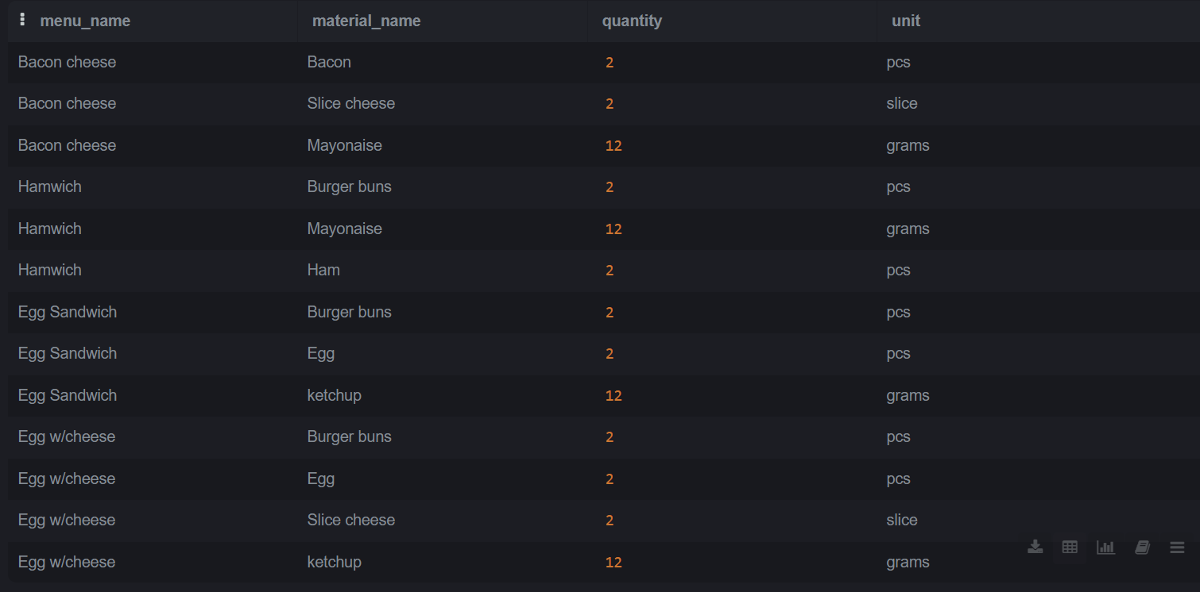
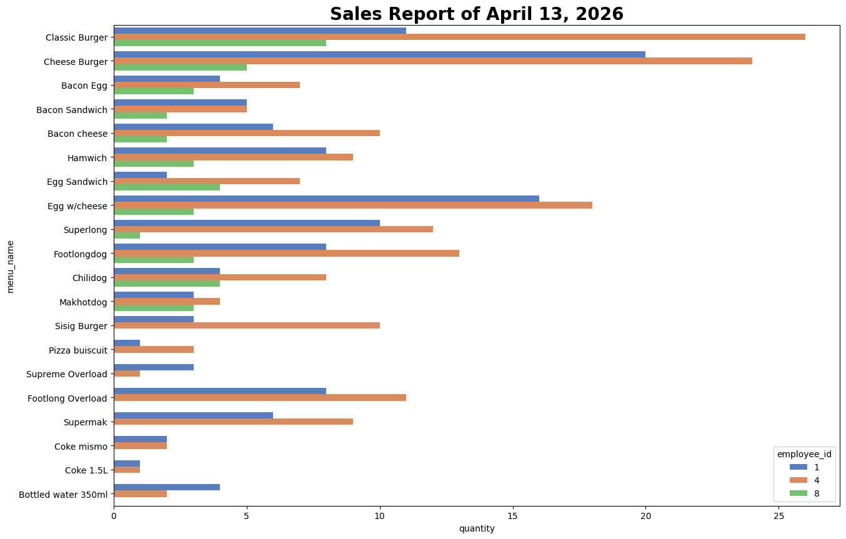
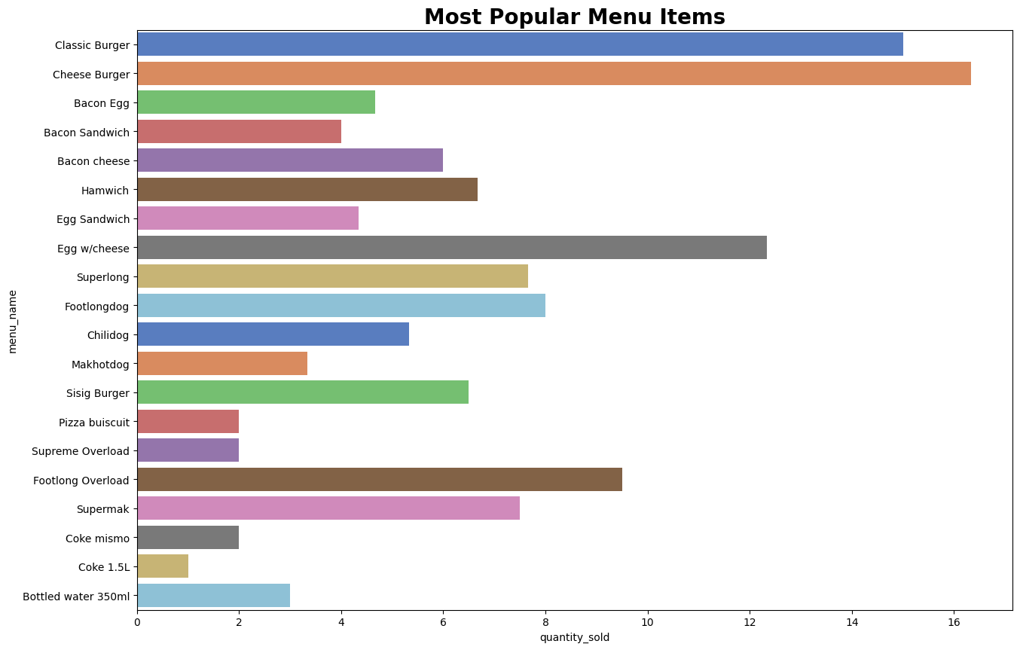
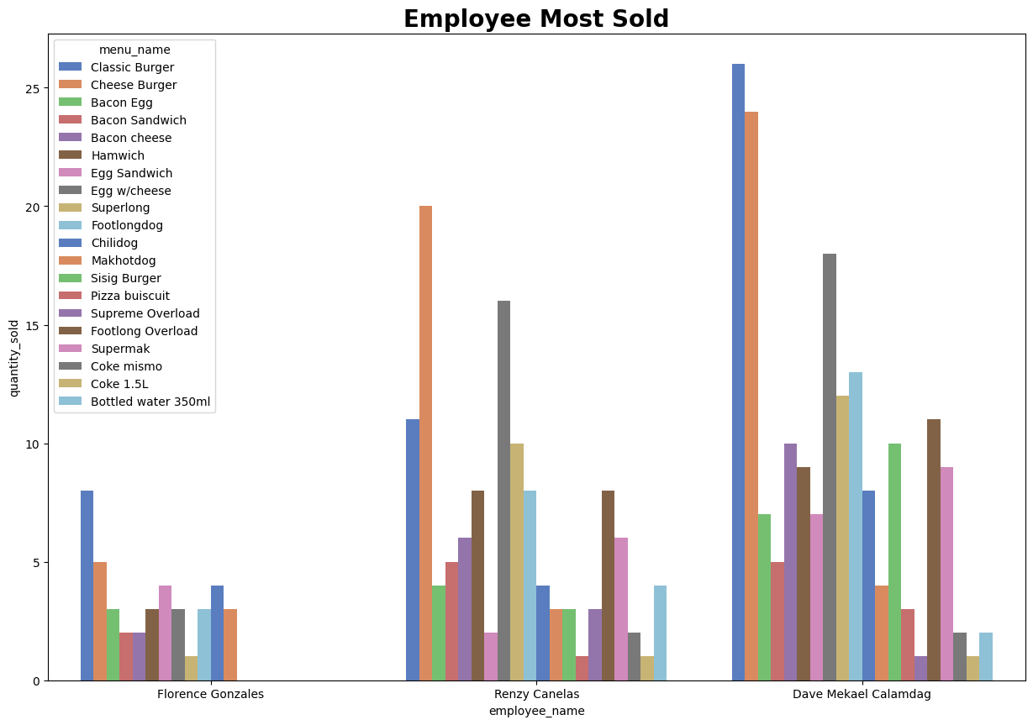
CONCLUSION AND RECOMMENDATIONS
Conclusion
The proposed database system provides a complete and structured solution for managing Big-Mac operations. By integrating sales, inventory, employees, menu items, and suppliers into one system, Big-Mac Franchise can achieve better accuracy, efficiency, and data-driven decision-making. This system will significantly improve operational control and support long-term business growth.
Recommendation
The implementation of this database system is highly recommended as it will significantly improve operational efficiency, enhance decision-making, and ensure better control over sales, inventory, and employee performance within the Big-Mac Franchise.

DOCUMENTATION
Week 1 - Brainstorming of Possible Study/Project
During the first week, we brainstormed ideas about who our client would be and identified possible questions to ask. We also discussed the structure of the database for the project.
Week 2 – Interview
On the second day, we went to the store of our chosen client, Ms. Bernadit Niemo, to conduct an interview for our database project in Information Management.


Day 3 - On the following day, we revised the questions from the interview we conducted with the client the previous day. Some of the additional details in the questionnaire were gathered directly from the crew, with permission from the owner to collect the data.


Week 3 – Creating of EDR (Entity-Relationship Diagram)
In the following weeks, we created an ERD.


Week 4 – Creating of Database
Database developer Mr. Ronel F. Oraye encoded collected data in database.
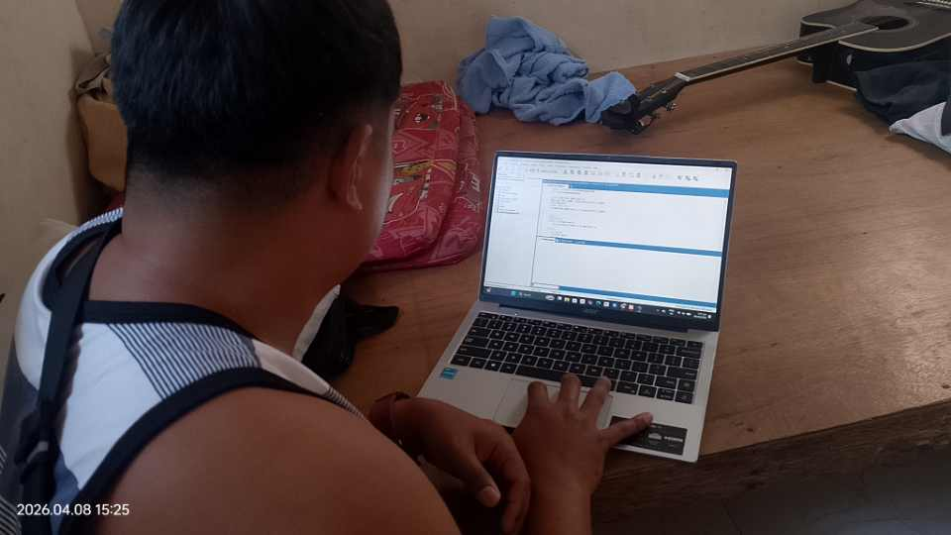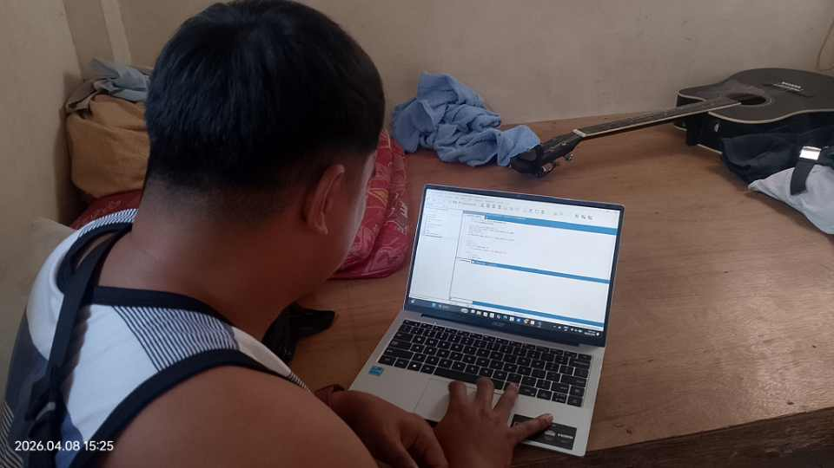
Week 5 – Review, revising gathered data
We reviewed all the information in our system, revising and updating several parts, including the system template and database queries. We also gathered additional relevant information; however, we did not document our progress.
Week 6 – Revising Database
We revised our database, including its entities and attributes. Moreover, we decided to implement our database using an online DBMS, specifically SQLite, because SQLyog was not working.

Week 7 – Finalization of the System
During this week, we focused on the finalization of our system. We reviewed all components, including the database structure, entities, attributes, and relationships, to ensure accuracy and consistency. Necessary revisions and improvements were made to the system interface, templates, and database queries. We also conducted final testing to identify and fix errors, ensuring that the system functions properly. Additionally, we verified that all features meet the required objectives and prepared the system for presentation and deployment.



